Ice Skating

**Wear proper clothes**. When ice skating, you should wear clothes that are easy to move around in and will not get heavy when wet. You want to be flexible and not too warm. Remember, skating is exercise so your body will get warmer once you move around.

[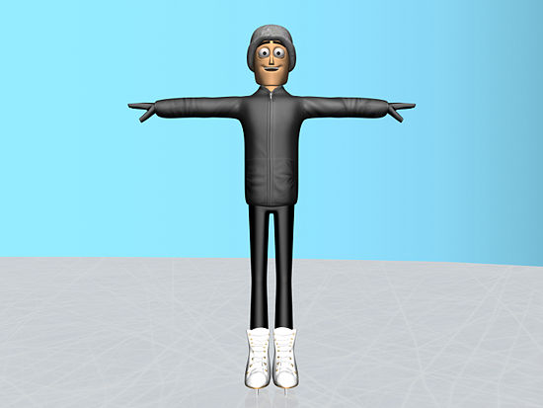](http://www.wikihow.com/Image:Ice-Skate-Step-1.jpg).

* + Don't wear jeans. Jeans are mostly rigid and harder to move around in. When you fall they can get damp and will be harder to skate in.

[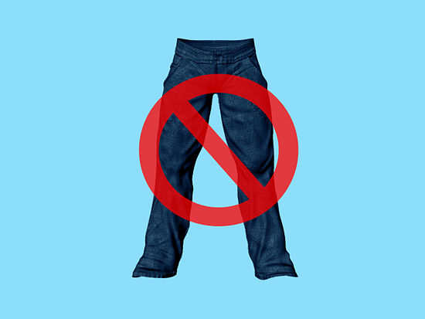](http://www.wikihow.com/Image:Ice-Skate-Step-1Bullet1.jpg)

* + Try some warm, thick leggings, a t-shirt, jacket, gloves, and hat.

[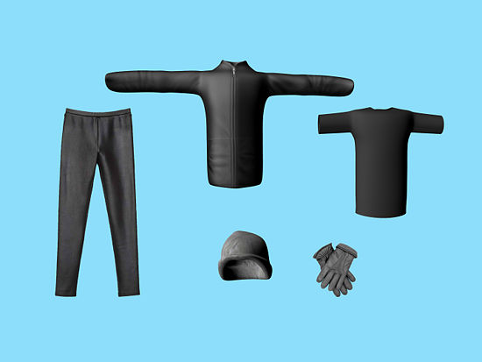](http://www.wikihow.com/Image:Ice-Skate-Step-1Bullet2.jpg)

1. 2

**Find good skates**. Skates should be fitted for comfort and are available in most shoe sizes. It's a good idea to measure both feet as one foot can be bigger than the other. Also, measure the width of your foot while sitting down. There are a number of good brands you can buy, but rentals are adequate for your first steps.

[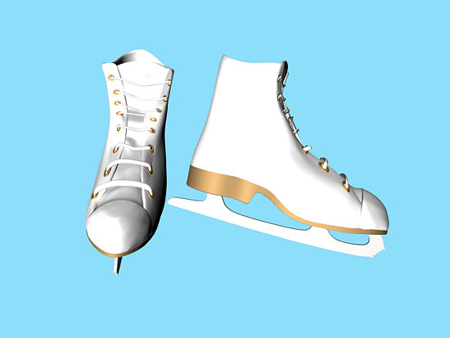](http://www.wikihow.com/Image:Ice-Skate-Step-2.jpg)

1. 3

**Try walking**. Most skate rinks have rubber matting you can walk on. Walk around to help maintain your center of gravity but remember to keep your skate guards on.

[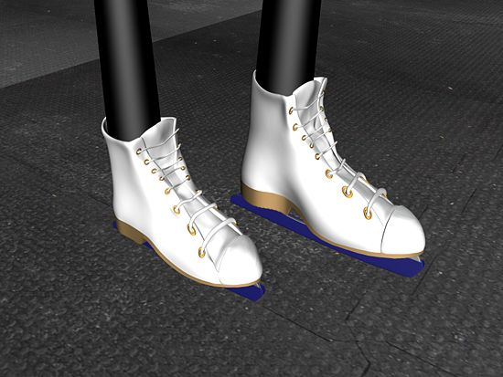](http://www.wikihow.com/Image:Ice-Skate-Step-3.jpeg)

* + The trick here is to get comfortable on skates. The more you're in your skates, the better your body adjusts to balancing itself. This is a learning process, so don't expect to be an expert right away
  + [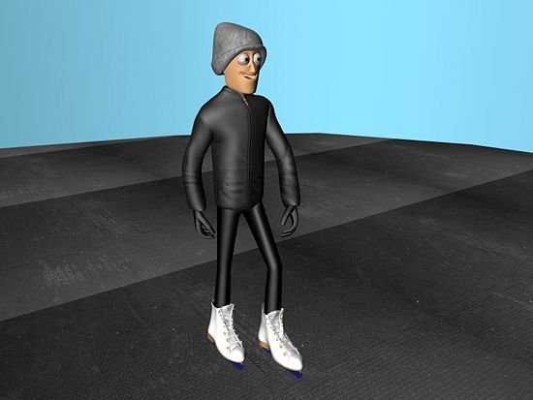](http://www.wikihow.com/Image:Ice-Skate-Step-3Bullet1.jpeg)
  + If you are wobbly walking around in your skates, focus on one point with your eyes and trust your body to get the balance right. Balancing is all about keeping your head steady and your eyes fixed on a point.

[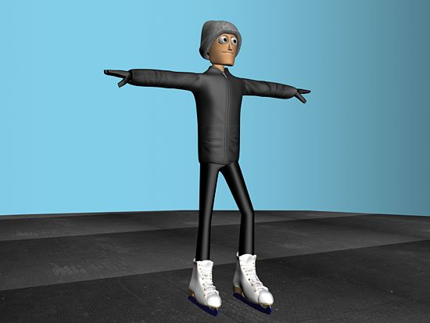](http://www.wikihow.com/Image:Ice-Skate-Step-3Bullet2.jpeg)

1. 4

**Get on the ice**. The keys to skating well are relaxation and technique, so relax and try to keep your legs as steady as possible. Learning to walk will help give you ankle support and help you get used to the friction of the ice.

[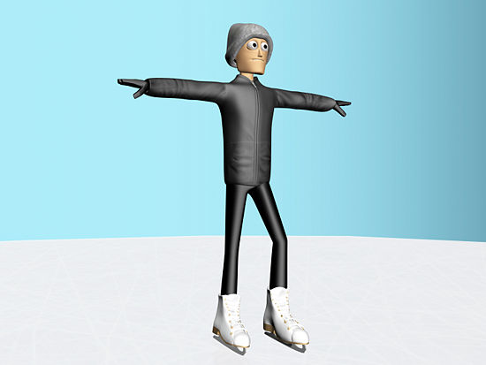](http://www.wikihow.com/Image:Ice-Skate-Step-4.jpg)

* + Walk around the edge of the rink while holding onto the wall. This will help you get a feel for the ice.

[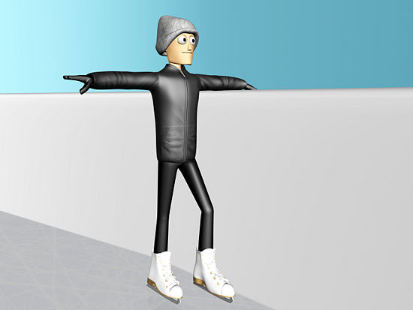](http://www.wikihow.com/Image:Ice-Skate-Step-4Bullet1.jpg)

* + Start slow. It won't feel natural at first, but take things slow and move fluidly. You're not going to win any speed contests the first couple times on skates. Avoid jerky movements. If you want, pretend you are a graceful animal moving through its natural habitat.

[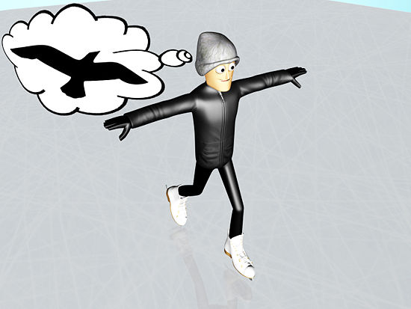](http://www.wikihow.com/Image:Ice-Skate-Step-4Bullet2.jpg)

1. 5

**Learn to maintain your balance**. While you learn this step, remember to move slowly. Eventually, the faster you go, the easier it will be to balance. So if you can learn to balance yourself going slower, moving faster will seem easy.

[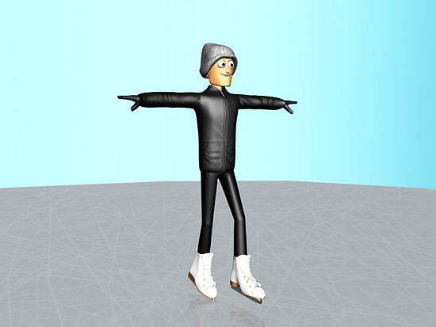](http://www.wikihow.com/Image:Ice-Skate-Step-5.jpg)

* + Start by holding your arms out at just below shoulder level to learn to balance yourself.

[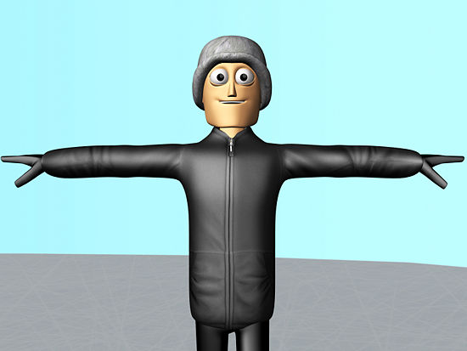](http://www.wikihow.com/Image:Ice-Skate-Step-5Bullet1.jpg)

* + Try not to stiffen your body. It actually makes skating harder. Keep your body loose and relaxed and you will find it much easier to glide along.

[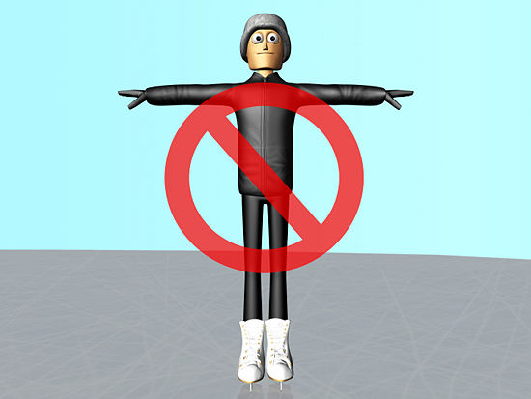](http://www.wikihow.com/Image:Ice-Skate-Step-5Bullet2.jpg)

* + Bend your knees slightly and lean forward, not back. Knees should be bent enough so that you can't see your toes and your shoulders should be forward and above your knees. Try not to hold onto anything. The wall can become a crutch.

[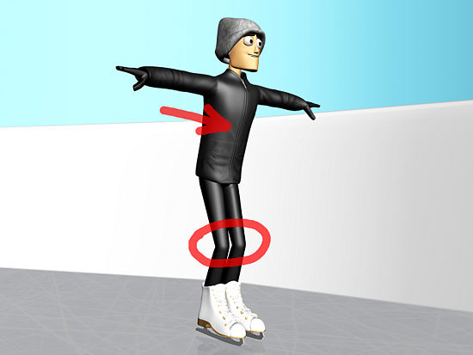](http://www.wikihow.com/Image:Ice-Skate-Step-5Bullet3.jpg)

* + You *will* fall a couple of times. Get back up, brush it off, and go back at it. Rome wasn't conquered in a day.

[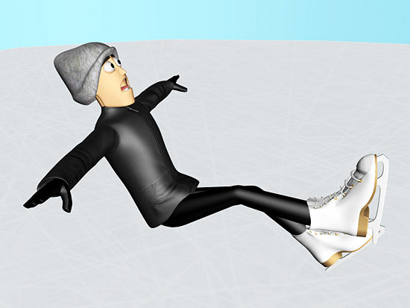](http://www.wikihow.com/Image:Ice-Skate-Step-5Bullet4.jpg)

1. 6

**Once you maintain good balance, try skating a little faster**. If you feel like you're going to fall, bend your knees and put your arms out on the side of you.

[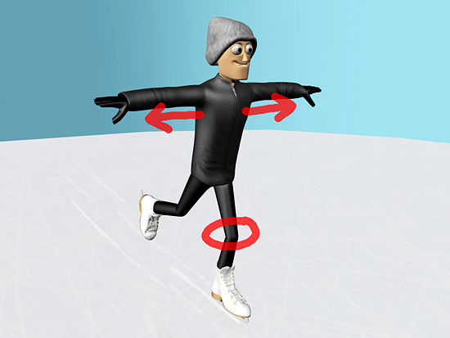](http://www.wikihow.com/Image:Ice-Skate-Step-6.jpg)

* + If you find yourself tripping as you skate, you are most likely "toe-picking." Make sure that when you put your blade down on the ice, it's level, and the toe pick isn't going down first.

[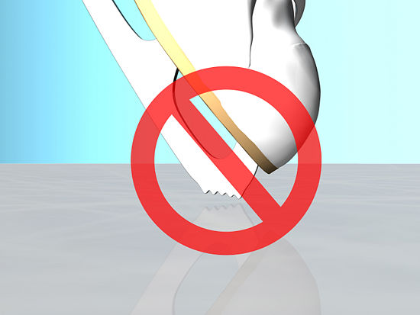](http://www.wikihow.com/Image:Ice-Skate-Step-6Bullet1.jpg)

1. 7

**Do squats**. Squatting will help strengthen your thighs and let you practice your balancing technique.

[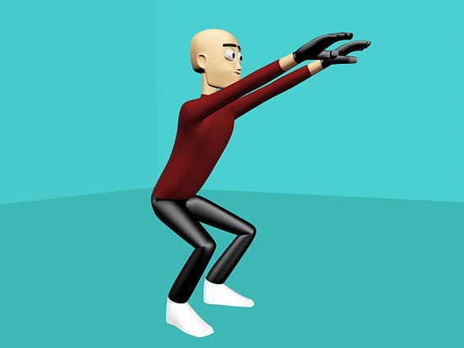](http://www.wikihow.com/Image:Ice-Skate-Step-7.jpg)

* + Stand up straight, feet at hip distance, and arms in front of you. Now, squat slightly, just enough to find your center of balance, and repeat a few times until you feel comfortable.

[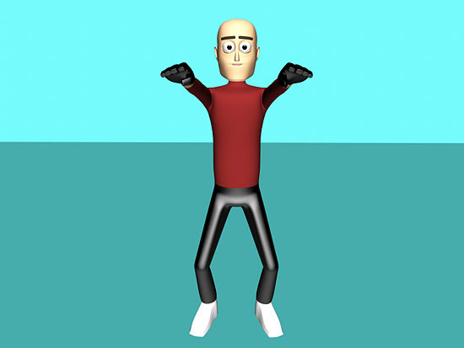](http://www.wikihow.com/Image:Ice-Skate-Step-7Bullet1.jpg)

* + When you're ready, try squatting further down, just until you feel your knees bending. Keep your eyes looking forward at all times.

[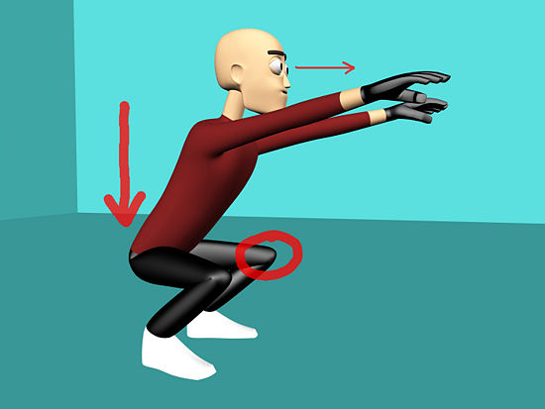](http://www.wikihow.com/Image:Ice-Skate-Step-7Bullet2.jpg)

1. 8

**Practice falling**. Falling is part of the sport so it's natural that this will happen. Falling with the right technique will keep you from getting injured and help you stay on the ice longer.

[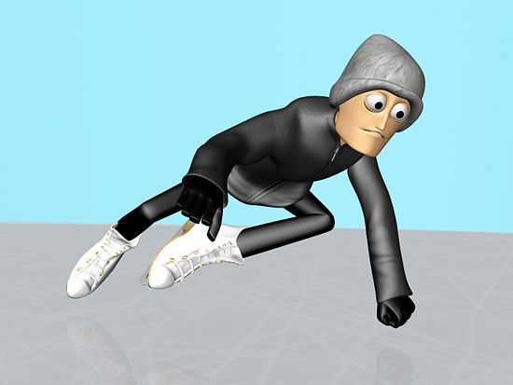](http://www.wikihow.com/Image:Ice-Skate-Step-8.jpg)

* + If you anticipate needing to fall, bend your knees and squat into a dip position.

[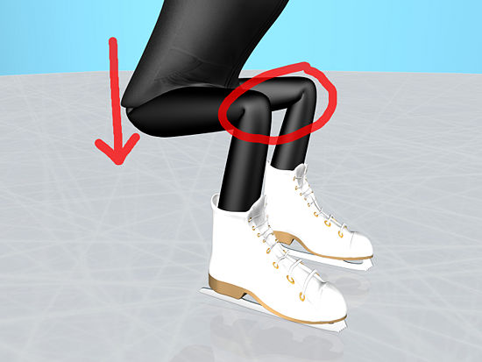](http://www.wikihow.com/Image:Ice-Skate-Step-8Bullet1.jpg)

* + Put your hands out to break your fall, quickly clenching your fingers into a fist so that you don't run the risk of losing any fingers from a passing skater.

[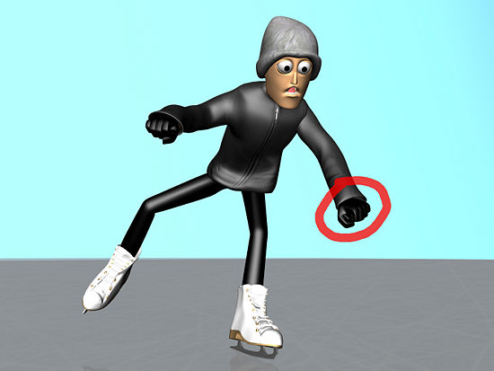](http://www.wikihow.com/Image:Ice-Skate-Step-8Bullet2.jpg)

* + Push your arms out so that they break the fall a little bit before your body hits the ice. You will have a safer fall.

[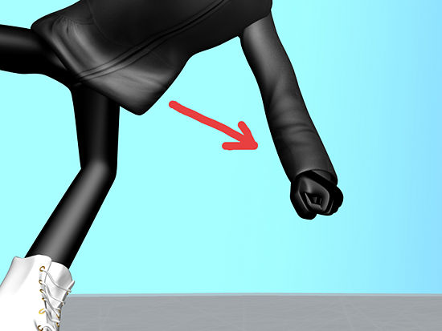](http://www.wikihow.com/Image:Ice-Skate-Step-8Bullet3.jpg)

1. 9

**Practice standing up**. Get on your hands and knees and place one foot between your hands. Repeat with your other foot and lift up until you are standing again.

[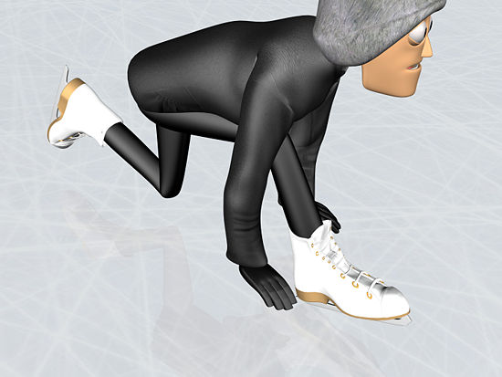](http://www.wikihow.com/Image:Ice-Skate-Step-9.jpg)

1. 10

**Move forward**. Lean on your weak foot, then, with your strong foot, pushing outward in a diagonal direction.

[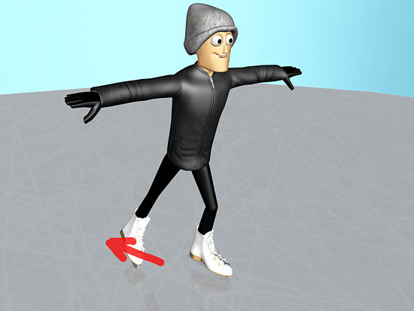](http://www.wikihow.com/Image:Ice-Skate-Step-10.jpg)

* + Pretend as though you're shoveling snow behind and to the right of you. This will propel you forward. Then bring the right foot back in next to the left and repeat the process.

[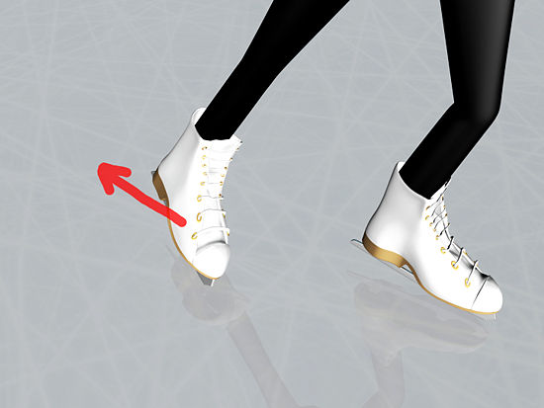](http://www.wikihow.com/Image:Ice-Skate-Step-10Bullet1.jpg)

1. 11

**Take longer strokes and try to glide**. Bend your knees and move your body with the strokes.

[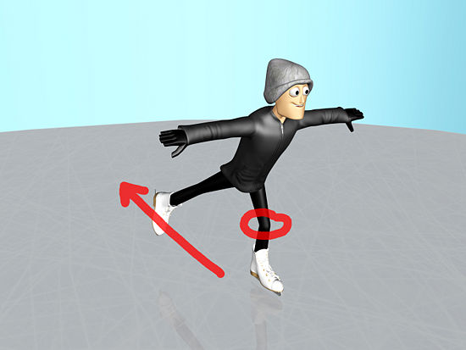](http://www.wikihow.com/Image:Ice-Skate-Step-11.jpg)

* + For gliding, make sure both skates are parallel to one another. If your skates are pointing the same angle, you'll go farther and faster. Pretend you're on an imaginary scooter that is on the ice.

[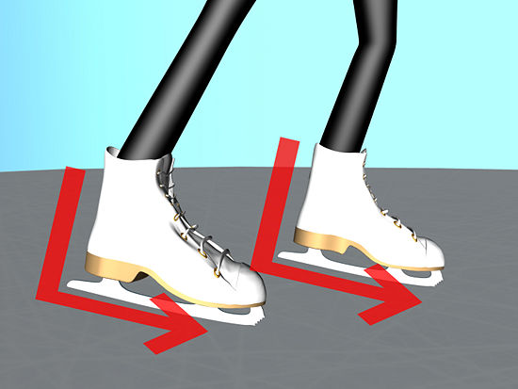](http://www.wikihow.com/Image:Ice-Skate-Step-11Bullet1.jpg)

* + If you try to give an extra flick of the toe/ankle at the end of each stroke, you will get more power and become a more efficient and faster skater.

[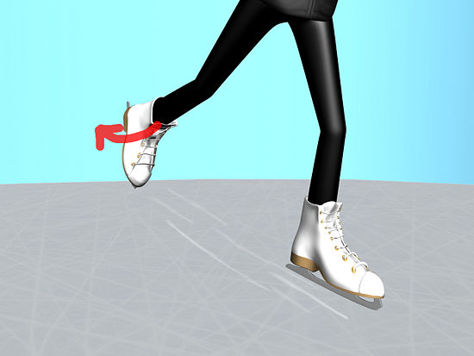](http://www.wikihow.com/Image:Ice-Skate-Step-11Bullet2.jpg)

1. 12

**Learn to stop**. To stop, bend your knees slightly inward and then push out with one or both of your feet.

[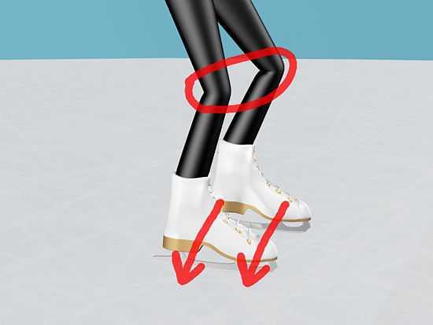](http://www.wikihow.com/Image:Ice-Skate-Step-12.jpg)

* + You should put a tiny bit of pressure on the ice so as your feet will not slide out from under you.

[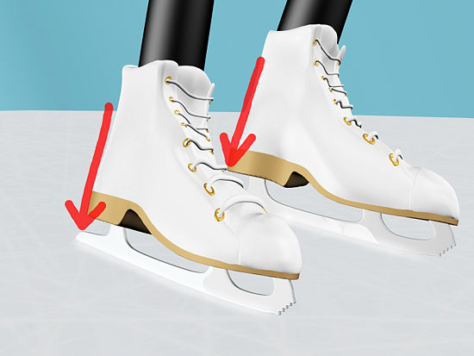](http://www.wikihow.com/Image:Ice-Skate-Step-12Bullet1.jpg)

* + When you stop, you should have created a little bit of "snow" that was sheered off from the ice.

[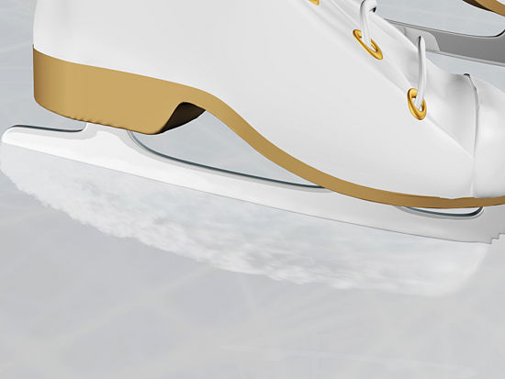](http://www.wikihow.com/Image:Ice-Skate-Step-12Bullet2.jpg)

1. 13

**Practice, practice, practice**. The more you practice these techniques, the better you'll be. Don't expect to be a pro the first time you step onto the ice.

[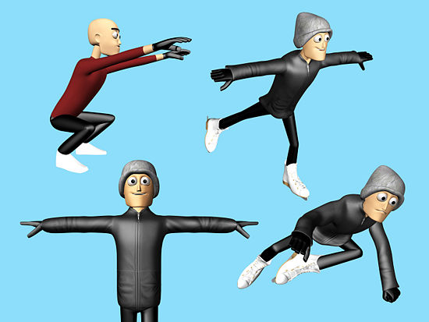](http://www.wikihow.com/Image:Ice-Skate-Step-13.jpg)

* + Take group or individual lessons if you can afford it. A teacher will be able to look at you on an individual basis and give you specialized tips.

[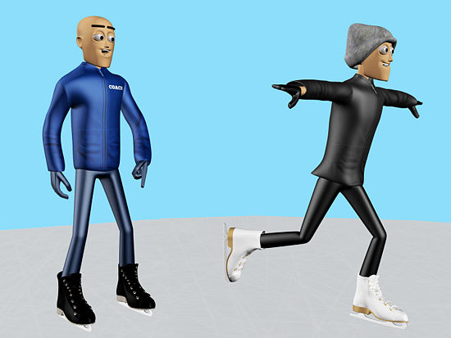](http://www.wikihow.com/Image:Ice-Skate-Step-13Bullet1.jpg)

* + Try roller blading whenever you're not on the ice. The technique is similar, and you're giving your body muscle-memory to rely on.

[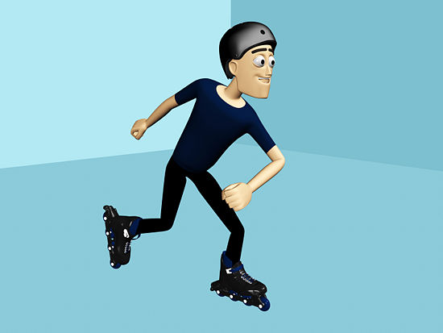](http://www.wikihow.com/Image:Ice-Skate-Step-13Bullet2.jpg)